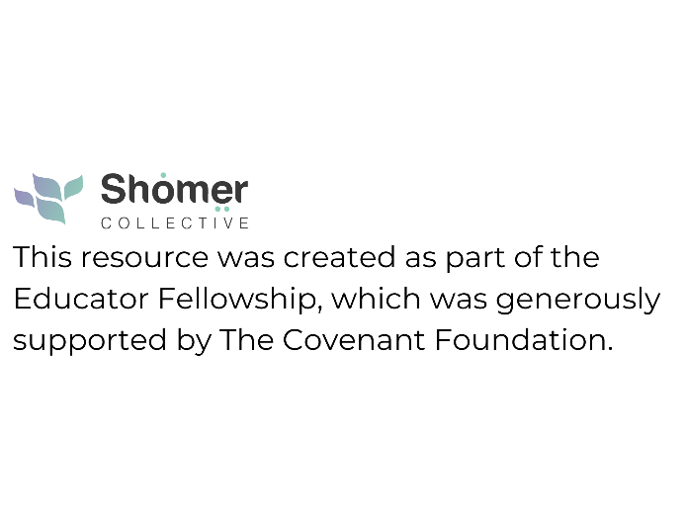

INTRODUCTION
The topics of death, dying, mourning and grief can be very challenging for children of all ages. This piece can serve as a helpful tool to examine our own approach to these topics and help us when navigating these difficult moments with children. It can be used as a guideline for educators and parents.
HOW TO TALK TO CHILDREN ABOUT DEATH, DYING AND GRIEF
UNDERSTANDING DEATH
- Irreversible death is permanent
- Final all functioning stops with death
- Inevitable death is universal for all living things
- Causality what causes death

GENERAL TIPS FOR TALKING WITH CHILDREN ABOUT LOSS
Young children are very concrete, and they do not understand the permanence of death. What is important to them is our affect as we answer their questions concretely and simply. Thery read our emotions and body language first and then decide if something is anxiety-producing or scary., Our emotions permeate theirs. Therefore, self-regulation and an understanding our own responses to death as a natural phenomenon of loss makes a difference.
- Be Honest and Gentle: Use clear, simple language. Instead of “passed away” or “went to sleep” say “died.” Stay away from euphemisms and do not lie.
- Normalize the conversation and Encourage Questions: Let them express their thoughts and fears. If you don’t know an answer, it’s okay to say, “I don’t know.”
- Only answer what is being asked.
- Validate Their Feelings: Assure them that it’s okay to feel sad, angry, or even confused.
- Your children are not you. Clarify your own beliefs

HELPING CHILDREN COPE WITH GRIEF
- Give reassurance: Young children may fear that they or others they love will die soon. Reassure them they are safe. Usually, people die when they are very old and sick…

- Offer Comforting Rituals: Drawing pictures, creating books about the deceased with photos and memories (pets as well), talking about them, writing letters

- Be patient: Grief can come in waves, and children may express it in play or behavior changes rather than words. Include teachers in the process.

AGE APPROPIRATE INFORMATION
- Address the questions being asked
- Recognize that children will learn from other sources
- Share proactively when appropriate
- Be present and patient

AGES AND STAGES
- Toddlers and Preschoolers
  - See death as temporary
  - Concrete thinkers
  - Language matters/no euphemisms

- Elementary School Aged Children
  - Understand finality of death
  - Worry about what will happen to their parents

- Tweens/Young Teens
  - Understand death, confused emotions about it
  - Start thinking “philosophically” about death
  - May have feelings of guilt/regret

Listen and observe: Questions and wonderings may come long after the specific death Children of all ages are constantly trying to understand the world, If they feel that they do not have a satisfactory answer, they will continue to ask until they feel comfortable. They can intuit when an answer is missing authenticity.

JEWISH DEATH AND MOURNING PRACTICES – can be very helpful to both children and adults.
1, FUNERAL - Very important to prep them as to what they will be seeing: Sad people, crying people etc. A designated caregiver (perhaps not an immediate mourner) should be assigned specifically to the child to shepherd them through the experience, answer quiet questions appropriately and be loving and caring toward the child.
2. BURIAL
3. SHIVA – young children could be involved in shiva, etc in age-appropriate ways. (e.g. help make food to bring, or come to the shiva to play, if their friends are among the mourners)
4. UNVEILING -Is there an age-appropriate role they can play in any of these events? i.e.Be involved in collecting and distributing rocks to the attendees for the headstone

RESOURCES
PJ Library How to Talk to Kids About Death and Dying |
Ideal18.org Programs Other Resources
Shomer Collective Resources
The Invisible String by Patrice Karst
When Dinosaurs Die by ALaurie Brown
Where is Poppy? By C. Pritchard
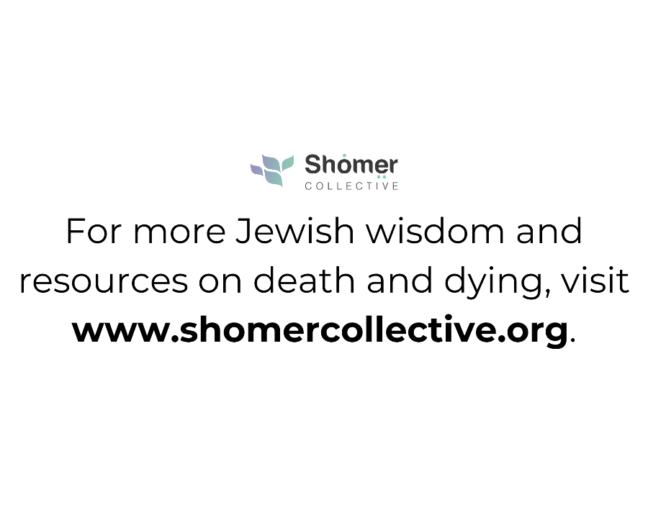
Something Very Sad Happened – A Toddler’s Gide to Understanding Death by Bonnie Zucker


