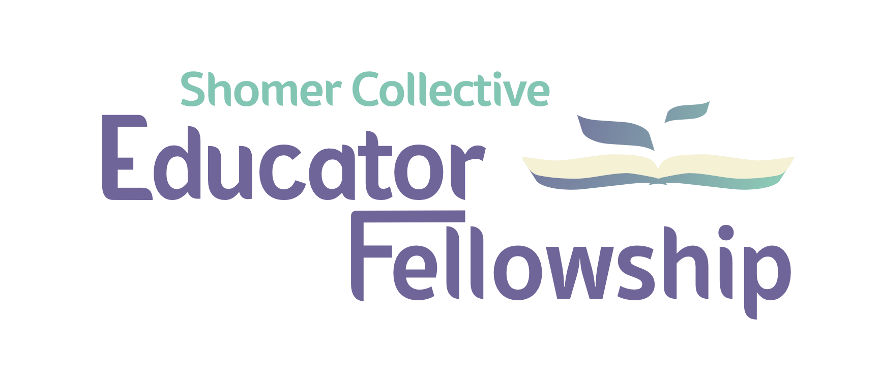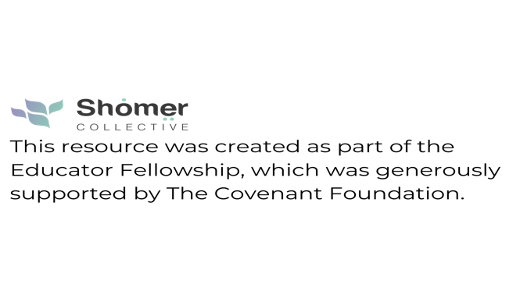

Leadership and Legacy

Learning goals: Students will learn about the concept of legacy, exploring how Biblical and modern Jewish leaders pass on their legacies.

Age: 8-18

Supplies: canvas/sheet for banner, markers for decorating

Teach the Hebrew phrase l’dor v’dor (from generation to generation.)

The essential question for today: “Legacy, what is a legacy? Planting seeds for a garden you’ll never get to see.” Who likes Hamilton?: https://www.youtube.com/watch?v=NrMkdZtqiVI

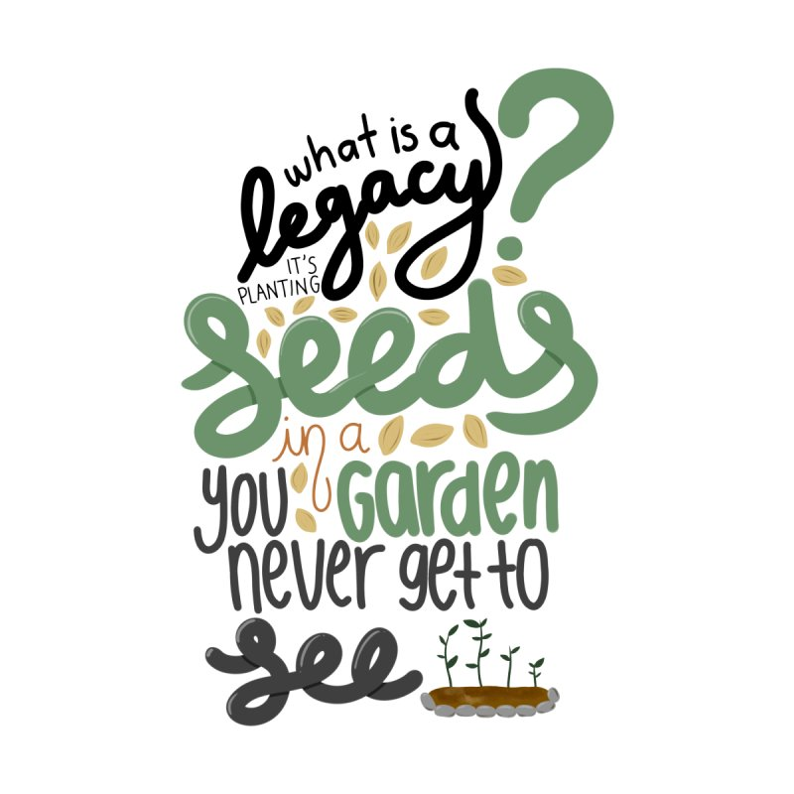

Legacy is the banner we carry, that others will pick up & continue carrying

Moses’ death:

WATCH: https://m.youtube.com/watch?v=nneAjOXnvJI

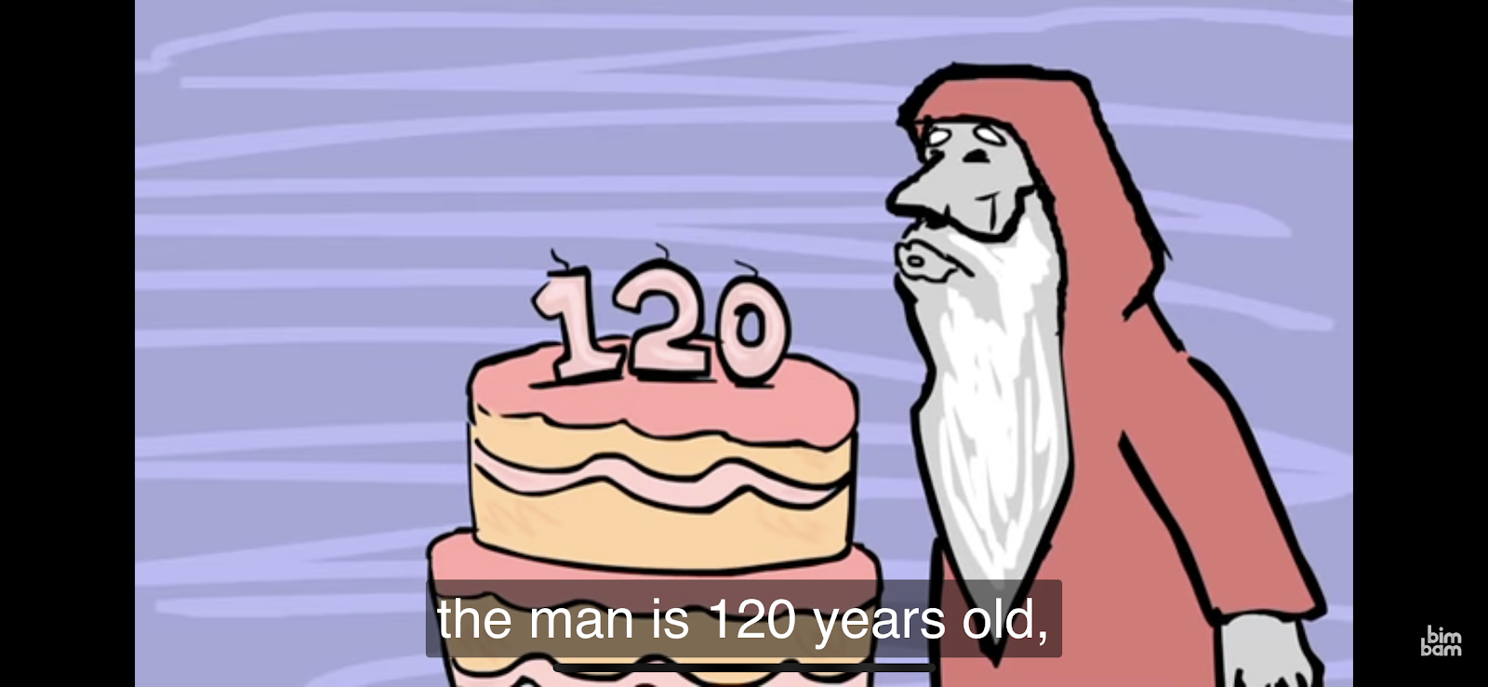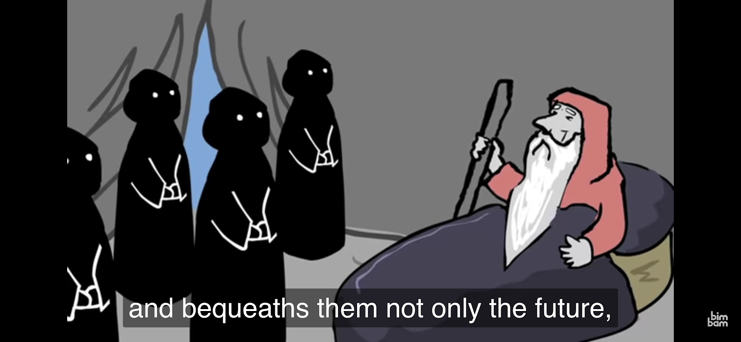
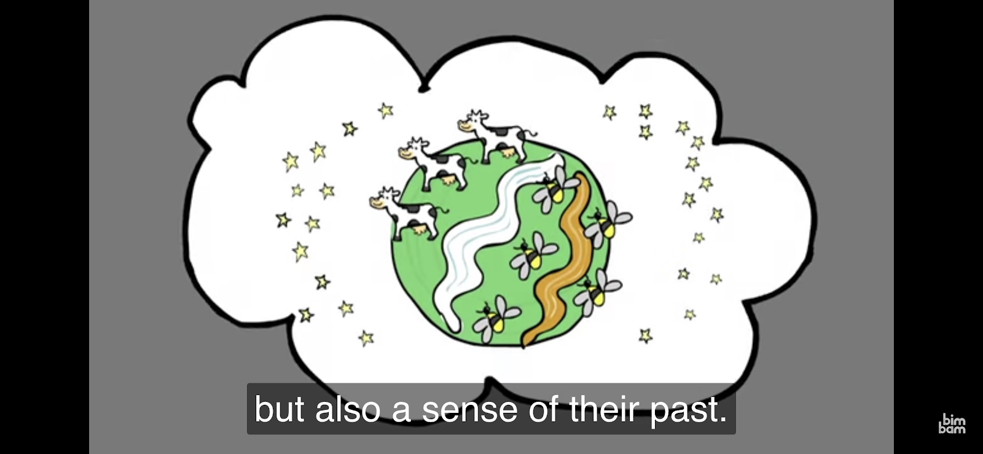

Moses is sharing a final lesson. It is common for people who are dying to share a lesson, which is their legacy. What is Moses teaching?

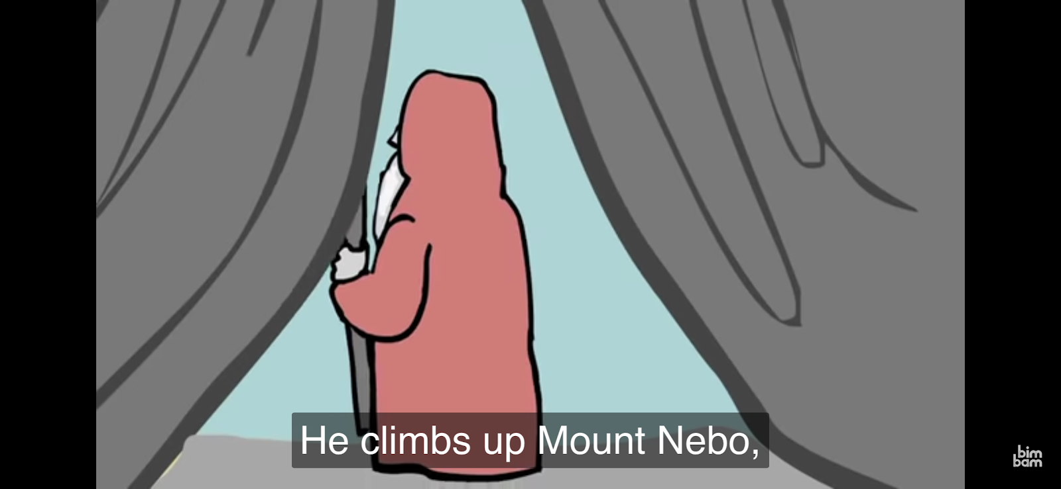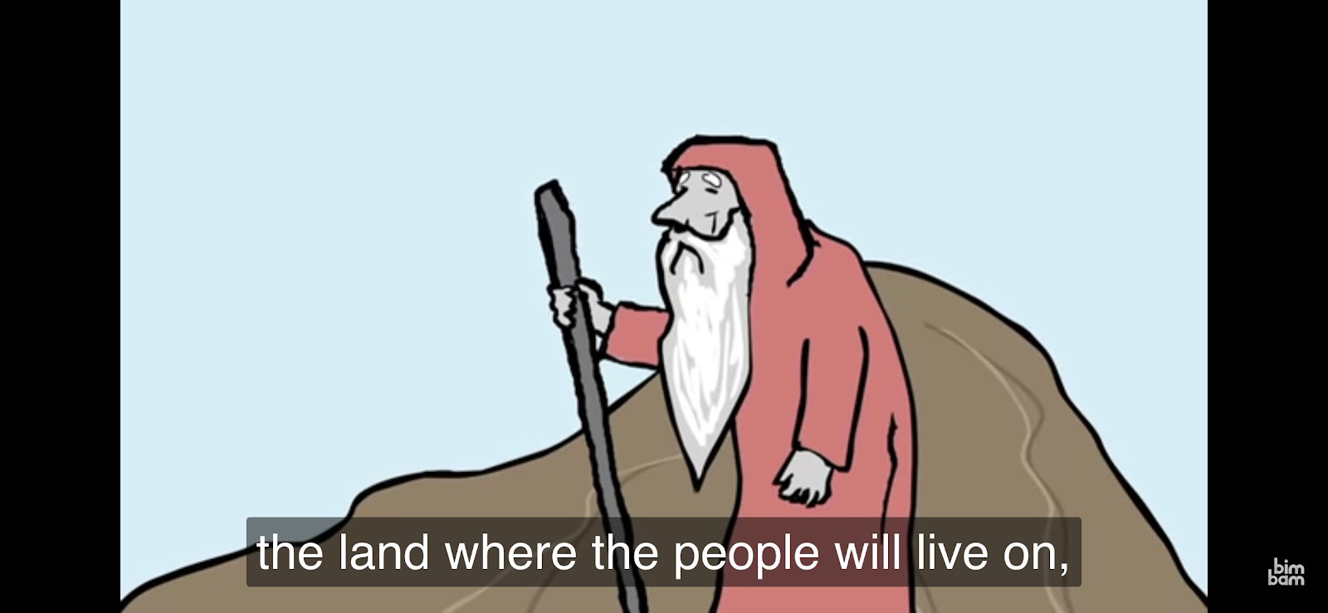
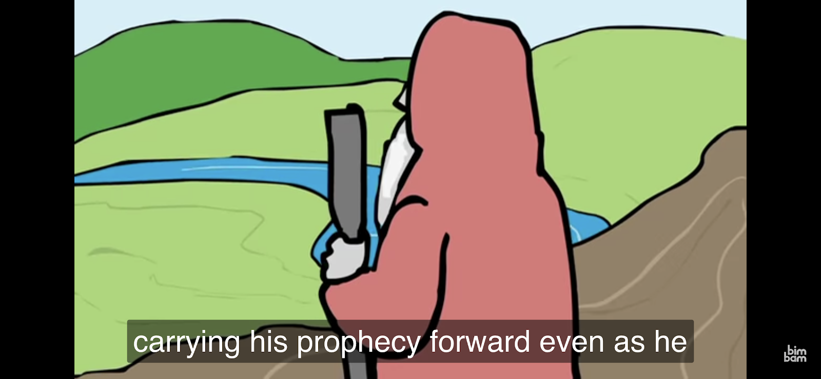

This is a threshold moment, a doorway moment. Movement activity: Have students walk through a doorway.

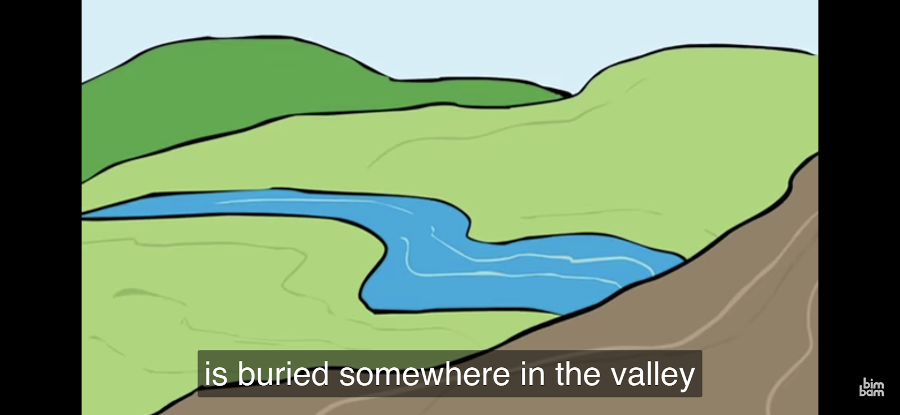
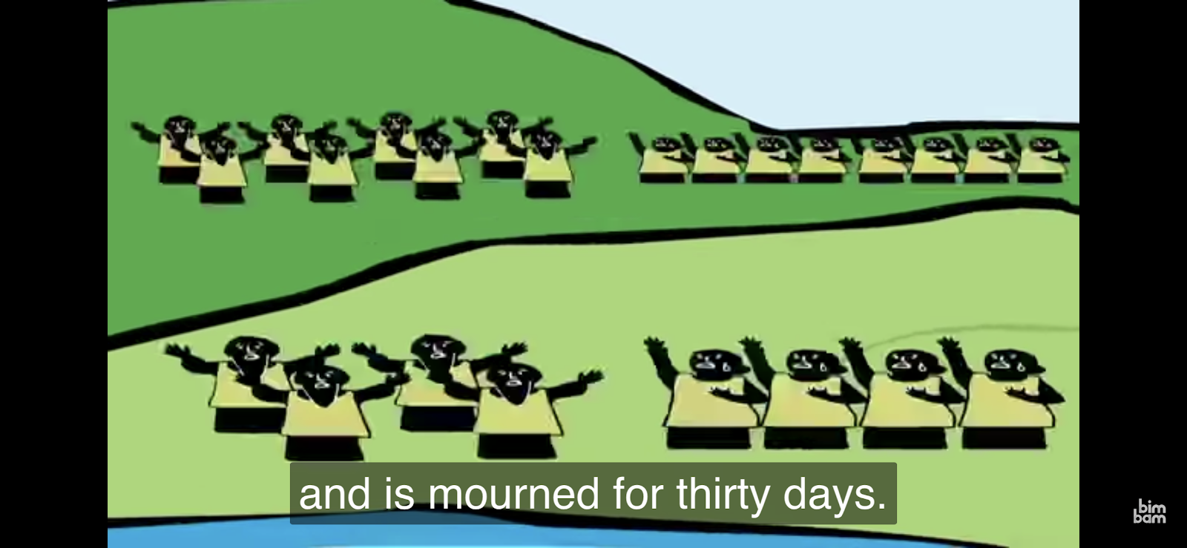

How did the community mourn for Moses, and for how long? In the Jewish tradition we mourn for thirty days, shloshim.

WATCH: https://m.youtube.com/watch?v=DLRCb3Zg_MQ&t=134s

Leadership transitions & Legacy

Leaders and visionaries don’t often get to see their visions play out.
What makes them prophetic is that they see farther than others, though they may not get to experience it for themselves. Instead, their legacy and work lives on. Who are some examples?

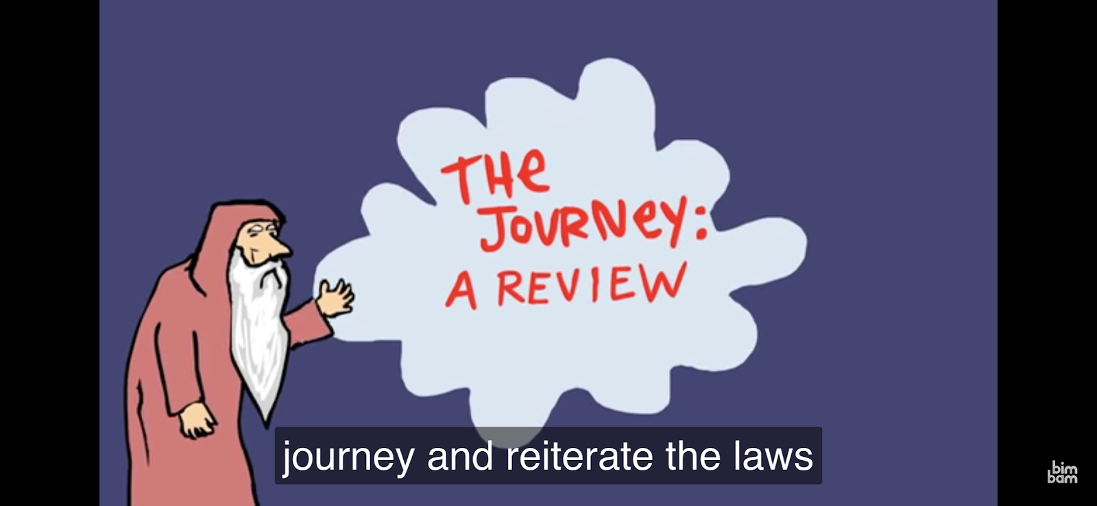
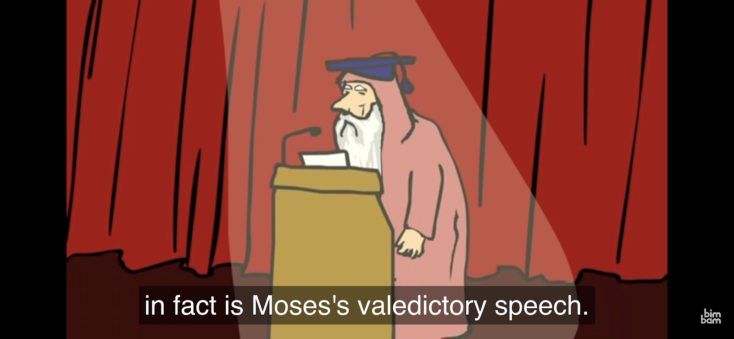
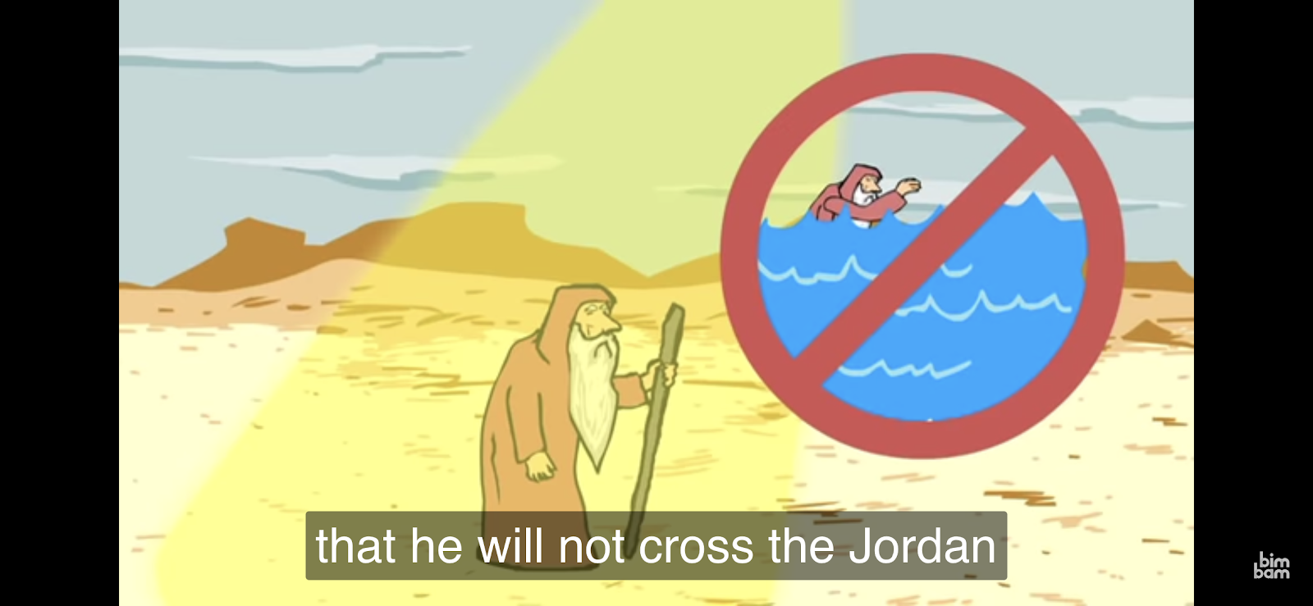
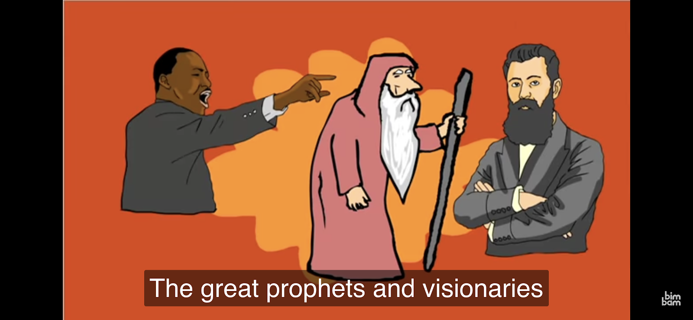
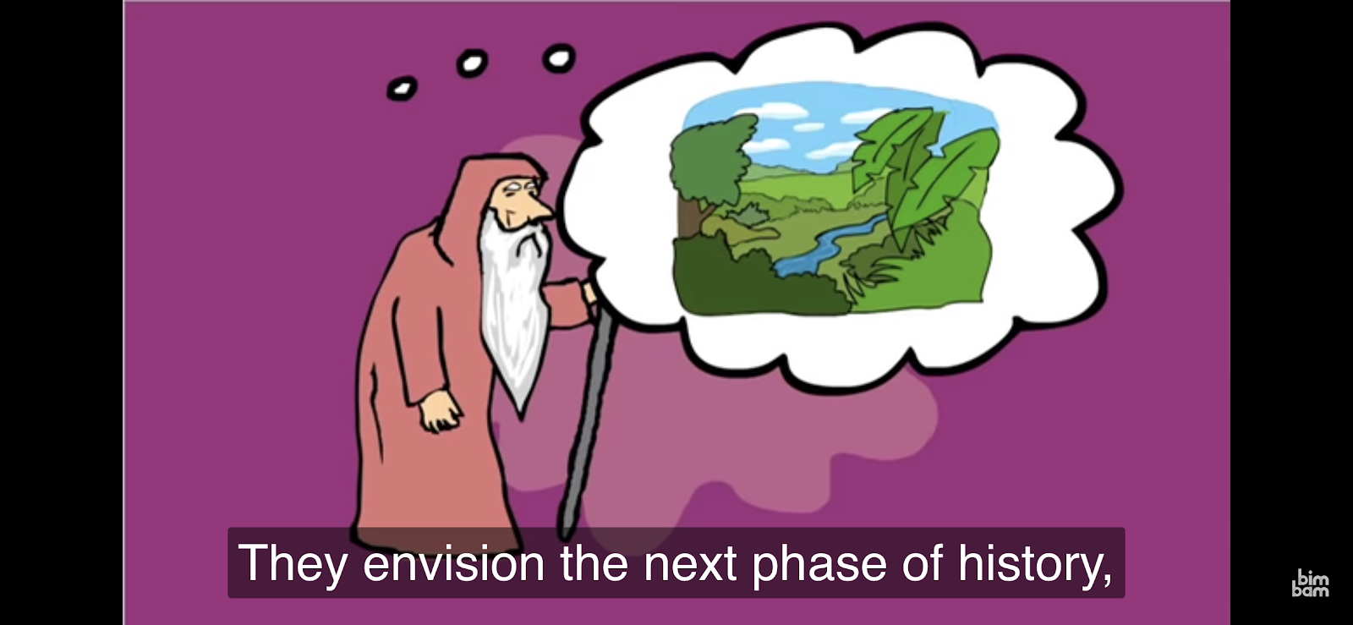

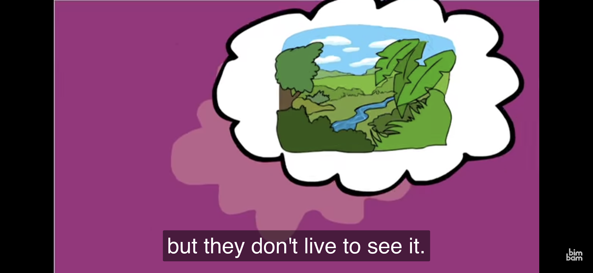
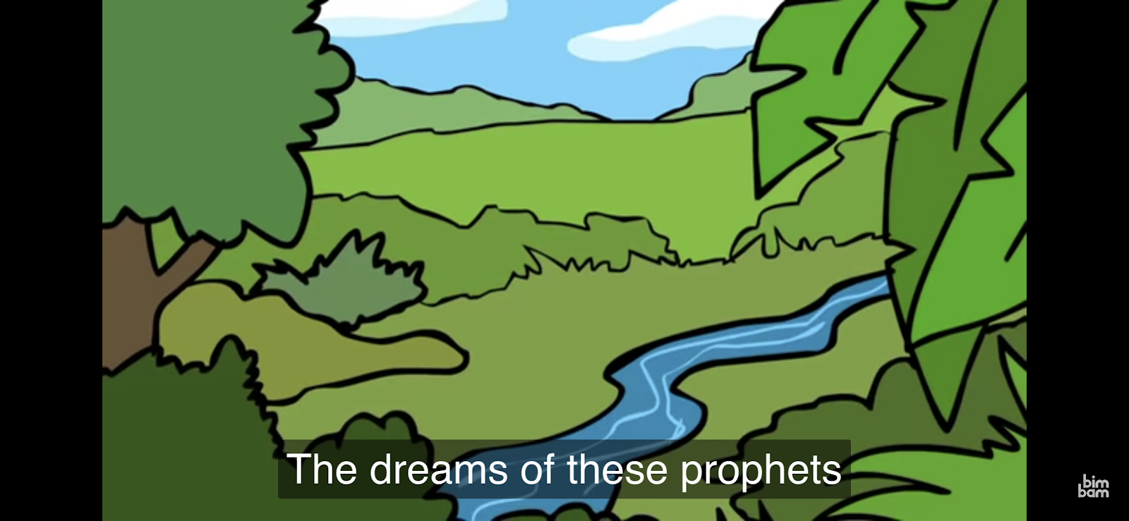
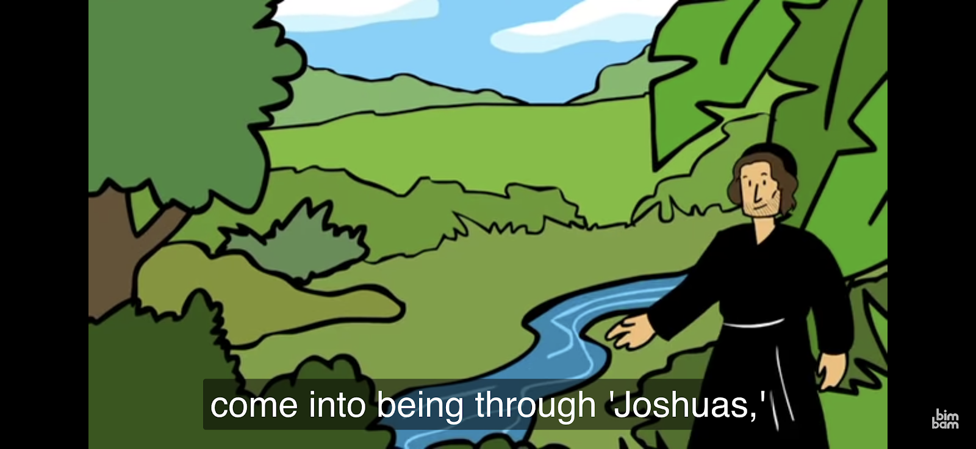
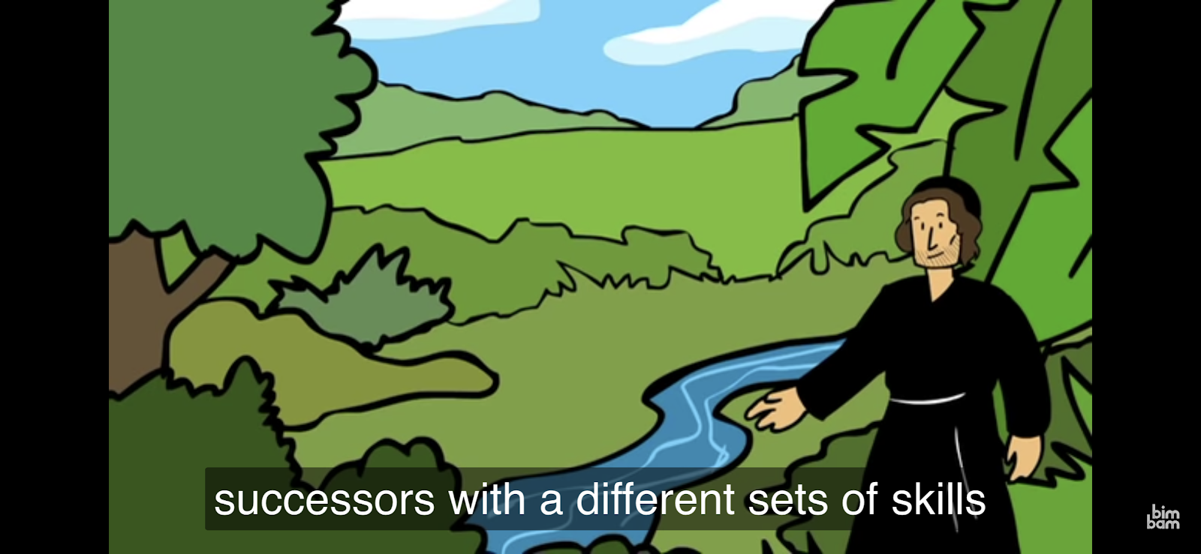
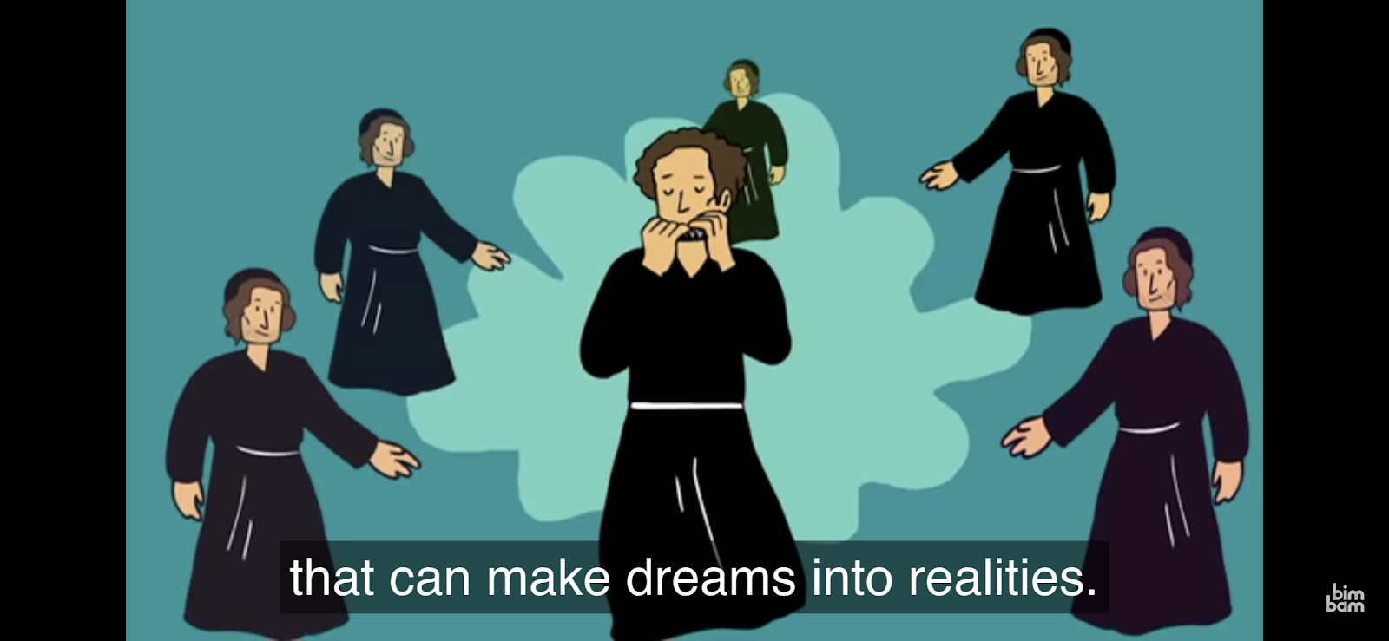
Discuss: There are Nachshons, Moses, Joshuas. There are many different kinds of leaders, and different types of leadership. Multiple roles are needed. What makes a Joshua different from a Moses? When might we need a Nachshon, or a Moses, or a Joshua?

Another person who did not live to see his legacy play out was Rabbi Emet Tauber. He passed away March 25, 2019 at the age of 24. He was a rabbinical student at the Reconstructionist Rabbinical College.

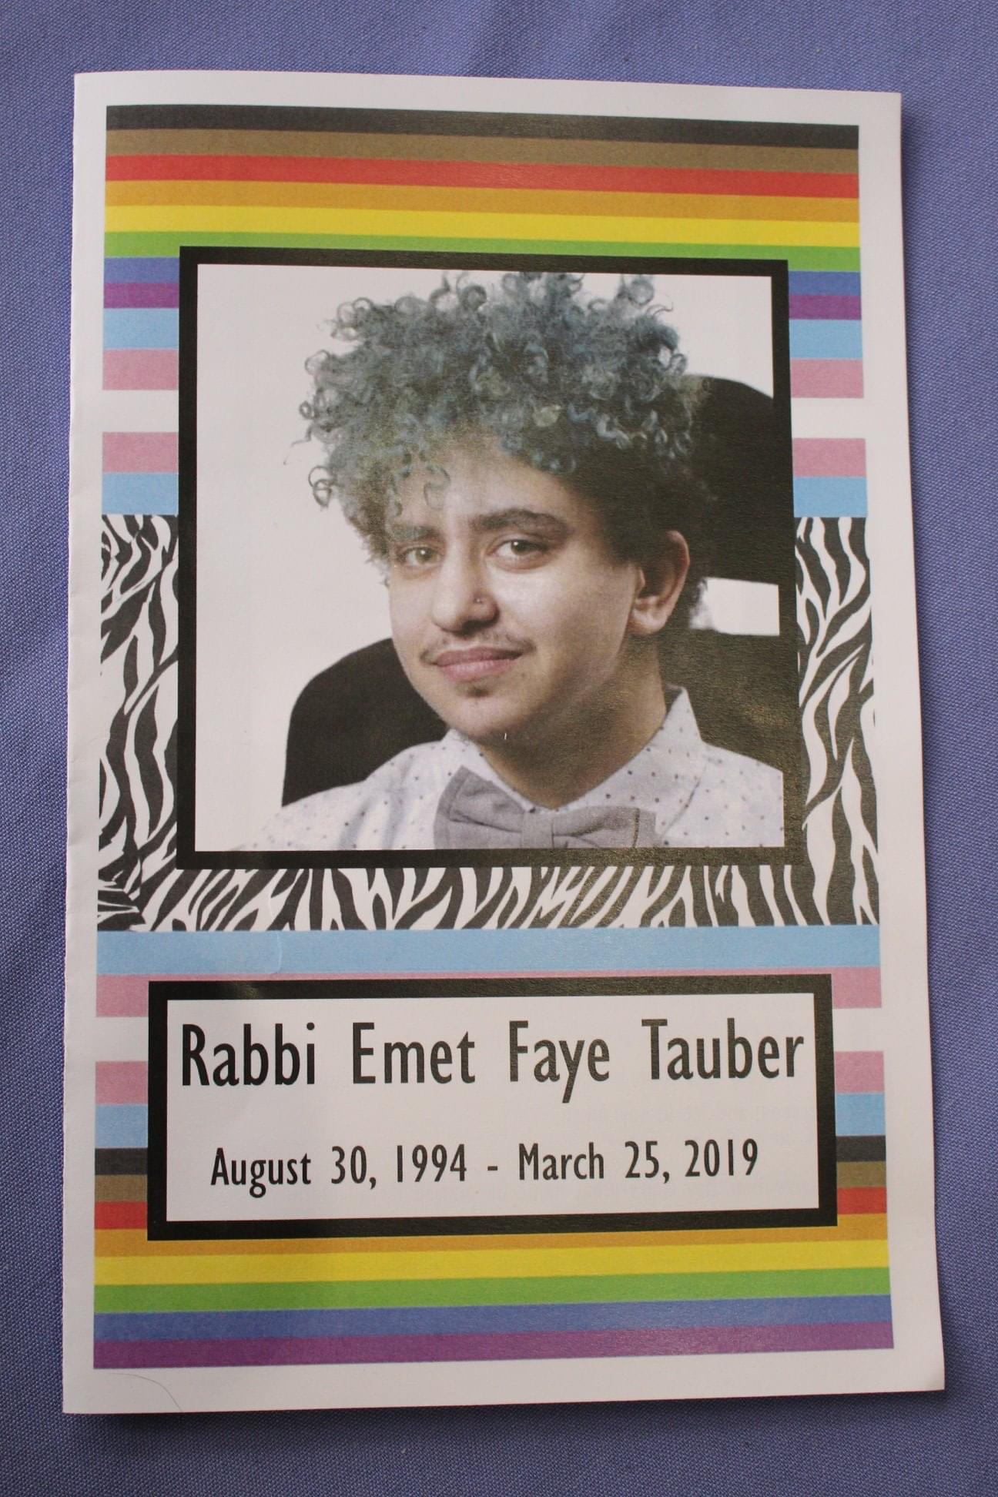

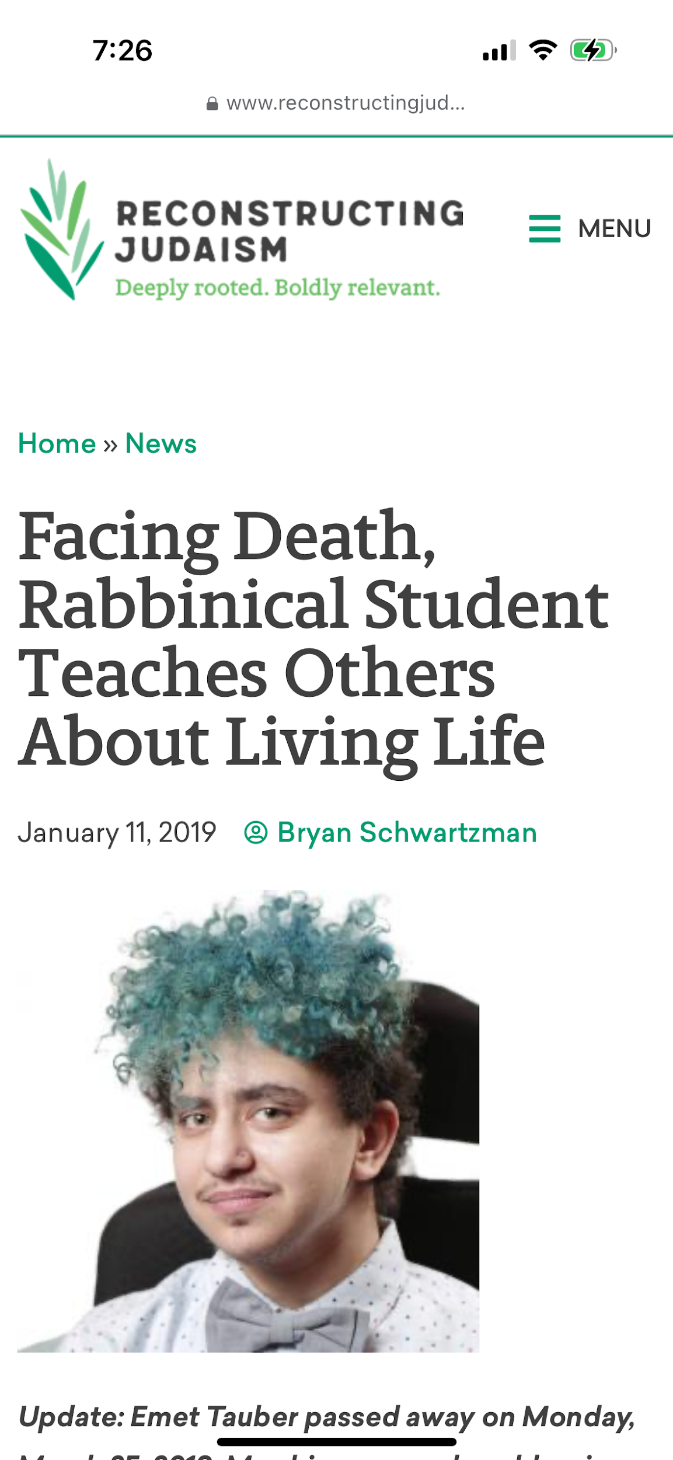

More information about Emet:
https://www.reconstructingjudaism.org/news/facing-death-rabbinical-student-teaches-others-about-living-life/

https://advocacymonitor.com/ncil-mourns-the-loss-of-emet-tauber/

https://www.facebook.com/IfNotNowOrg/posts/emet-tauber-a-beloved-member-of-ifnotnow-philly-died-monday-night-from-complicat/2180797588673864/

https://disabilityvisibilityproject.com/2022/08/14/emet-tauber-disabled-oracle/

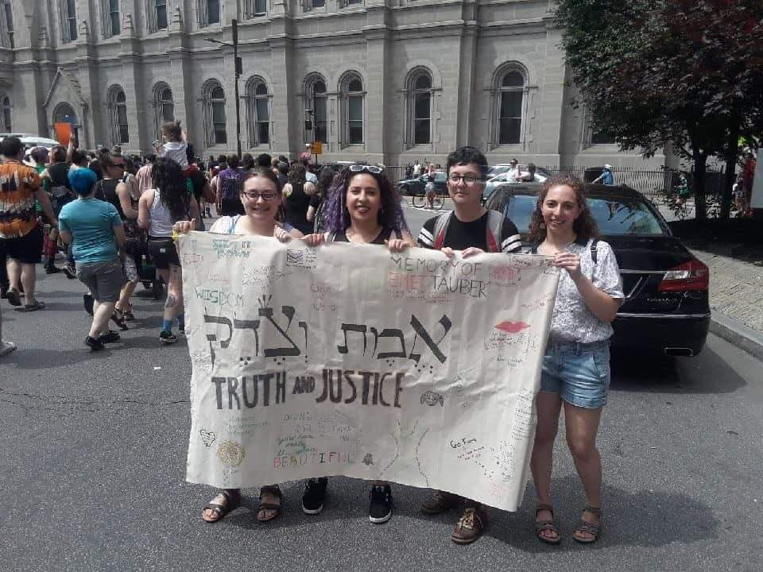
Emet’s banner carried by Jordan Parnell, Sarah Giskin, and Daniel Holtzman at Philadelphia Dyke March 2019

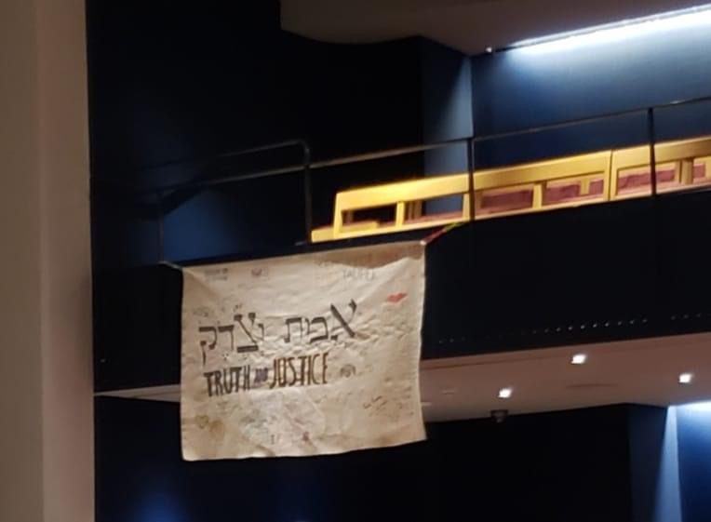
Emet’s banner displayed at the Trans Jews are Here conference at Congregation Beit Simchat Torah, NYC, March 30, 2019.

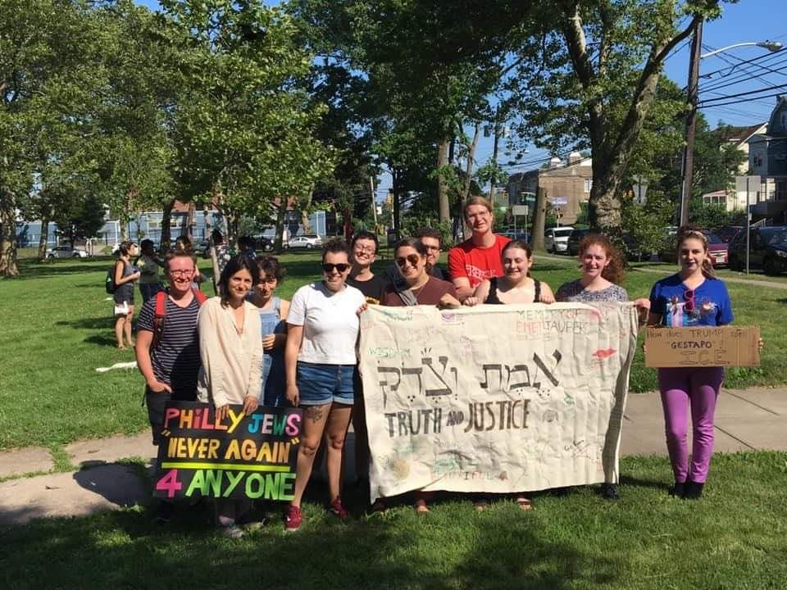
Emet’s banner carried by Asher, Jenny, Shir, Daniel, Josh, Davi, Jordan Parnell at a protest of Immigration Customs Enforcement, July 2019

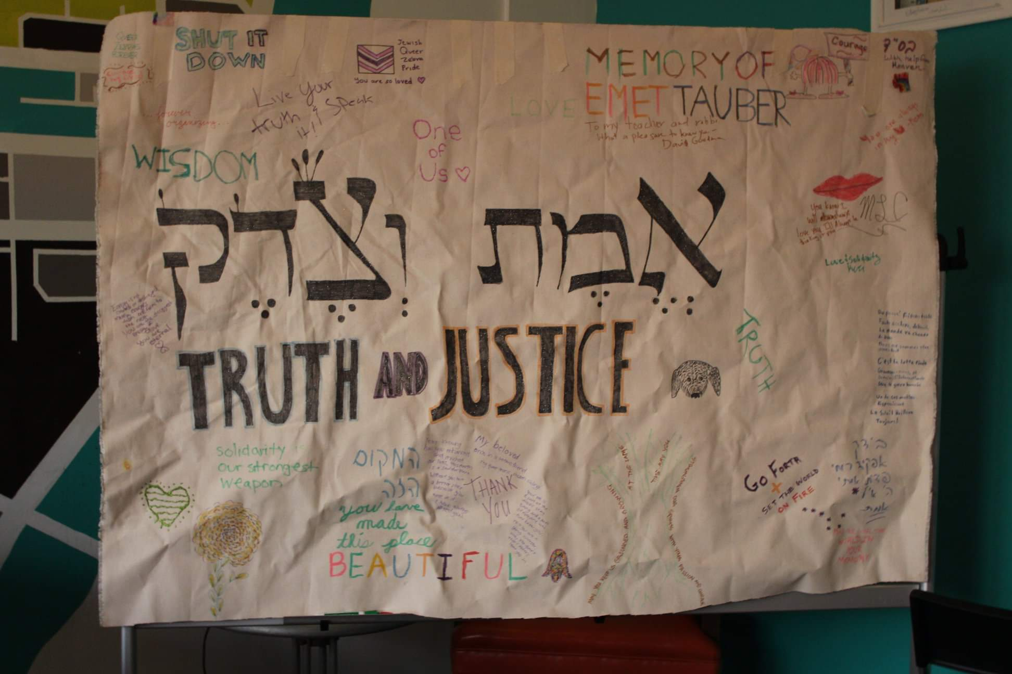
Emet’s banner displayed during shiva at Repair the World Philadelphia

What do you see on Emet’s banner? What legacy did he want to pass on?
Where is Emet’s banner being carried in the pictures? What might you put on your banner and where might you carry it?

Emet spent his last months of his life teaching us how to live life, and ensuring his legacy would outlast him by creating scholarships.

What did Emet teach people? What did they learn about how to live?

WATCH: https://share.icloud.com/photos/0feEMPoe7f5xGb4iKo0JIlCFA

How did Shir feel helping Emet? What was helpful for Shir as a young person facing grief and losing a friend for the first time? How did Shir’s friends help each other? What was helpful about Judaism?

Movement activity:

History and leadership are not a sprint, it’s a generational, marathon relay. Do a relay. Choose an object, such as a marker or a book, and have students stand spaced out around the room/hallway. Give one student the object and have them walk/jog to the next person and hand over the object. Leadership is a relay. Each generation picks up the banner where the previous generation left it. How far can we get in a generation? We pick up the banner where it was left, and we keep on marching.

Craft: make a memory/legacy banner- what will be on your banner that others will pick up after you? What will be your legacy?

Movement: Walk with completed banner

